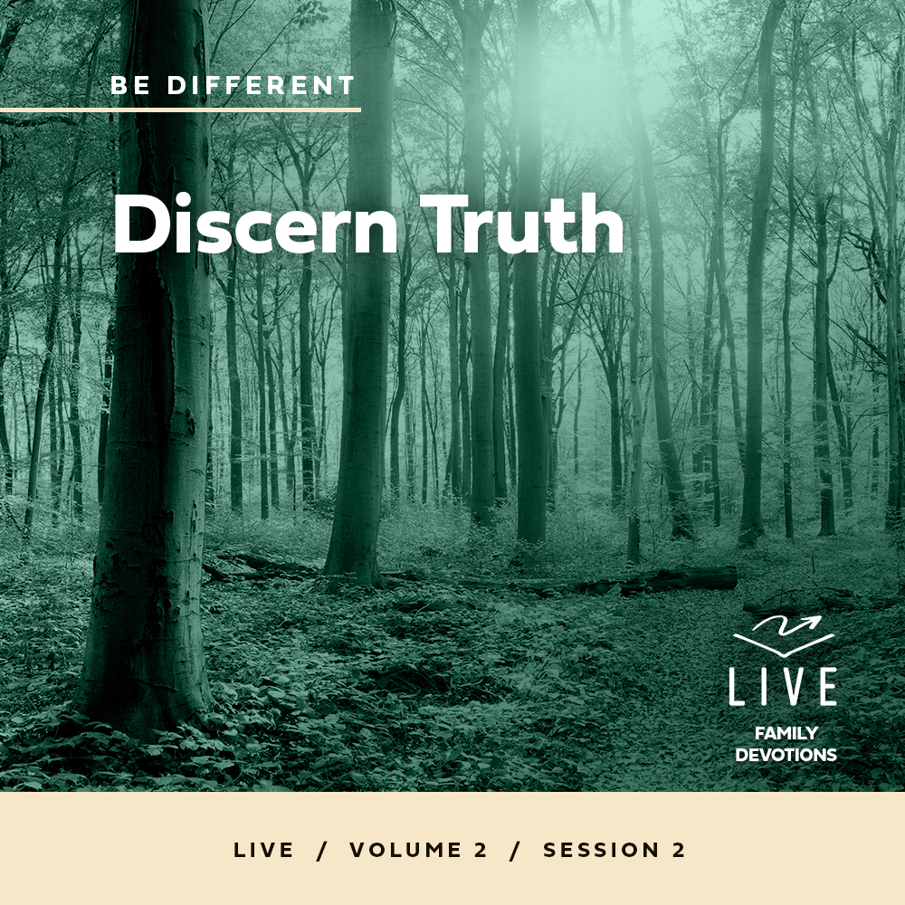
Day 1
Faith Fact
I can know the truth.
Faith Verse
Romans 12:2 (NLT)
Don’t copy the behavior and customs of this world, but let God transform you into a new person by changing the way you think.
Question of the Day: Who is Jesus?
Read about It
Read: Matthew 16:13–20
Have you ever heard a rumor about someone? Maybe it was rumor about a new kid or a teacher. People love to make guesses about other people’s lives. It was the same with Jesus. He healed the sick, did miracles, and taught in ways that were different. Many people had lots of guesses about who Jesus was, but the guesses in today’s verses were all wrong.
When Jesus asked the disciples who they thought He was, Simon Peter didn’t need to make guesses. He knew the truth about who Jesus was because God had shown or revealed it to him. He knew that Jesus was the Messiah, the Son of God. Just like Simon Peter knew the truth about Jesus, we can also know the truth. When we ask God to help us, He will reveal His truth to us.
Talk about It
Question 1. In the Bible verses we read, who did some people believe Jesus was?
Answer 1. They thought He was John the Baptist, Elijah, Jeremiah, or another prophet. (Matthew 16:14)
Question 2. How do you think the disciples felt when Jesus asked them who they thought He was?
Answer 2. Answers will vary.

Question 3. How did Simon Peter know the truth about Jesus?
Answer 3. Jesus told Peter, “My Father in heaven has revealed this to you.” (Matthew 16:17)

Question 4. Why do you think Jesus wanted the disciples not to tell anyone?
Answer 4. Answers will vary.

Question 5. Who is Jesus?
Answer 5. The Messiah, the Son of God (Matthew 16:16)
Pray about It
Dear Jesus, help us know the truth of who You are and how we should live because of that. Amen.

Day 2
Faith Fact
I can know the truth.
Faith Verse
Romans 12:2 (NLT)
Don’t copy the behavior and customs of this world, but let God transform you into a new person by changing the way you think.
Question of the Day: What does it look like to follow Jesus?
Read about It
Read: Matthew 16:21–24
Have you ever been tempted to play instead of work? It can be hard to choose to obey your parent’s instructions to clean your room instead of watching TV or playing video games. In today’s Bible verses, Jesus was frustrated with Peter. The enemy was using Peter against Jesus. But Jesus knew what He must do and that it would be hard.
We all face temptations to live a relaxing and comfortable life. But Jesus never promised us that life with Him would be easy. Jesus suffered for us on the Cross. His followers must also take up their cross and endure whatever challenges come their way. Following Jesus means we give up our own plans to follow Him. No matter how difficult it gets, we can trust Jesus and remember how much He has done for us.
Talk about It
Question 1. What did Jesus tell the disciples that the elders, priests, and religious teachers would do to Him?
Answer 1. “He would be killed, but on the third day he would be raised from the dead.” (Matthew 16:21)

Question 2. Who did Jesus say was using Peter’s words to tempt Him?
Answer 2. Satan, the devil (Matthew 16:23)

Question 3. Why do you think Peter rejected what Jesus was saying about His death?
Answer 3. What Jesus said didn’t fit what Peter thought would happen. Answers will vary.
Question 4. How do you think Peter felt after Jesus’ rebuke?
Answer 4. Answers will vary.

Question 5. What does it look like to follow Jesus?
Answer 5. Answers will vary.

Pray about It
Dear Jesus, help us to give up our own plans, pick up our cross, and follow You. Amen.

Day 3
Faith Fact
I can know the truth.
Faith Verse
Romans 12:2 (NLT)
Don’t copy the behavior and customs of this world, but let God transform you into a new person by changing the way you think.
Question of the Day: How can we know the truth about ourself?
Read about It
Read: Hebrews 4:12–13
Have you ever tried to mix oil with water? No matter how much you stir, they don’t completely mix! When it comes to mixing the truth with lies, it’s almost the opposite. It can be hard to tell them apart. The writer of Hebrews reminds us that it’s the word of God that helps us separate truth about ourself from lies.
God’s Word is true. That’s why it is important that we read our Bible. When we have thoughts or desires, we should always compare them to God’s Word. God’s Word will always help show the lies we are believing about ourself or our situation. When we listen to God’s Word, it leads us to truth.
Talk about It
Question 1. How does Hebrews 4:12 describe the word of God?
Answer 1. It is “alive and powerful. It is sharper than the sharpest two-edged sword.” (Hebrews 4:12)

Question 2. When we do something wrong, can we hide it from God?
Answer 2. No. “Nothing in all creation is hidden from God.” (Hebrews 4:13)

Question 3. Why should we trust God’s Word?
Answer 3. Answers will vary.

Question 4. How do you think God’s Word exposes our thoughts and desires?
Answer 4. When we read the Bible, the words will speak to our heart and mind to help us know what is right and what is wrong. Answers will vary.

Question 5. How can we know the truth?
Answer 5. Answers will vary.

Pray about It
Dear Jesus, please help expose any lies that we have believed and help us to see the truth in God’s Word. Amen.

Day 4
Faith Fact
I can know the truth.
Faith Verse
Romans 12:2 (NLT)
Don’t copy the behavior and customs of this world, but let God transform you into a new person by changing the way you think.
Question of the Day: Why don’t some people believe the truth?
Read about It
Read: 1 Corinthians 2:10–14
Have you ever listened to someone speaking a foreign language? When you don’t know the language, it can sound strange. Paul tells us that this is how unbelievers can feel when they hear Christians talking about the truth of God’s Word. Some people think differently from God, but we know that God knows best. As Christians, God’s Spirit lives in us and He shows us the truth.
Other people might not understand the truth of God’s Word. They might even think we are wrong to believe it. But we can be confident in the truth because we know the Holy Spirit has revealed or shown it to us.
Talk about It
Question 1. Who does verse 10 say revealed God’s truth to Paul?
Answer 1. God’s Spirit (1 Corinthians 2:10)

Question 2. What is the difference between human wisdom and God’s truth?
Answer 2. Answers will vary.

Question 3. How can we know God’s truth?
Answer 3. “No one can know God’s thoughts except God’s own Spirit. And we have received God’s Spirit.” (1 Corinthians 2:11–12)

Question 4. How should we treat people who don’t understand God’s truth?
Answer 4. Answers will vary.

Question 5. Why do some people not believe the truth?
Answer 5. It sounds foolish or silly to them. (1 Corinthians 2:14)

Pray about It
Dear God, thank You for giving us Your Spirit. Help us not to rely on human wisdom but to follow Your truth. Amen.

